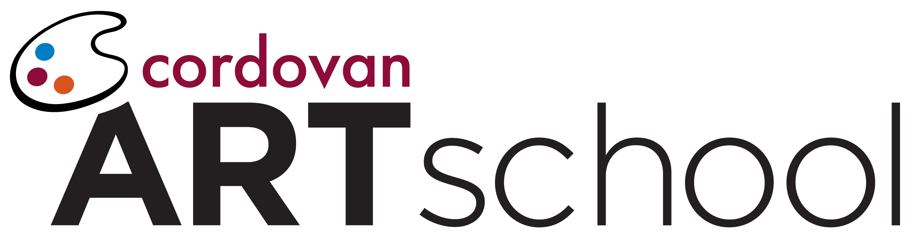
Suggested Policy or Procedure Change Form

I suggest alteration to the content in Section _______________________________ of the Brand Standards Manual.

Outline of suggestion:

Rationale for suggestion:

_____________________________ ______________
Franchisee Name Date

_____________________________
Franchisee Signature

_____________________________
Studio #

_____________________________
Address

_____________________________
City, State, Zip

