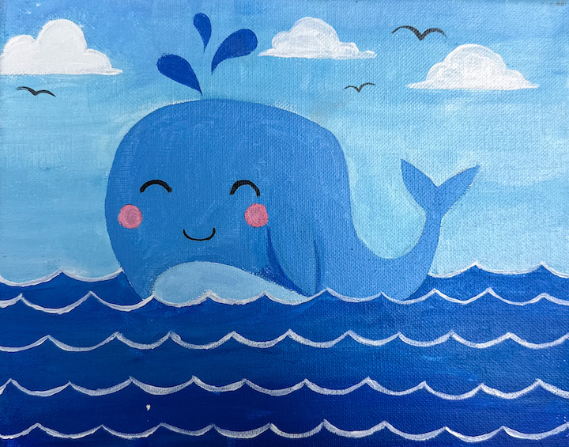
Happy Whale

Ages: 5-12

Materials: Canvas, acrylics, paintbrushes, white pastel pencil, paper towel

Art Techniques  - Layering  - Blending  - Blocking in Shapes | Art Elements  - Line  - Shape  - Value | Art Principles  - Emphasis  - Balance  - Movement Rhythm
Instructions
- Paint the entire canvas light blue. Let dry.
- Using a white pencil pastel, draw the whale, the clouds, and the wavy horizon line.
- Wipe away any lines you don’t want to keep using a slightly damp paper towel.
- Block in the clouds, water, whale and birds.
- Using a white pencil pastel, draw the wavy lines for the water, and the whales face.
- Paint the water lines and the whales face and add any final touches.

